**AH1 Huey Cobra Prime Pictures**

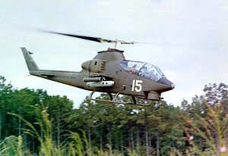

Bell AH-1G Huey Cobra

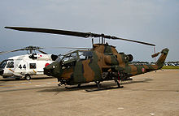

JGSDF AH-1S

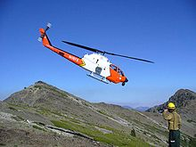

U.S. Forest Service Bell 209 on the Bar Complex Fire in California. USFS photo.

Bell 209

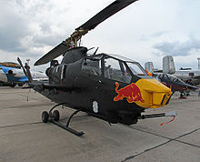

A late-model AH-1 Cobra at ILA 2006 in Berlin

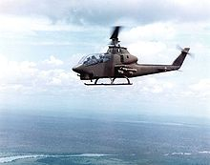

Bell AH-1G over Vietnam

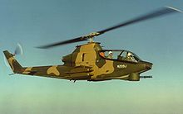

Bell 209 prototype of the AH-1 Cobra series, with skids retracted (FAA no. N209J)

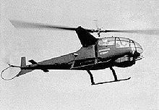

Bell Model 207 Sioux Scout

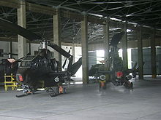

Two Pakistani Army AH-1S Cobras at AVN Base, Multan

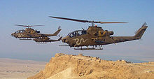

Three Israeli AH-1F Cobras over Masada

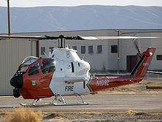

USFS Bell 209 at Fox Field during the California wildfires of October 2007

Bahrain